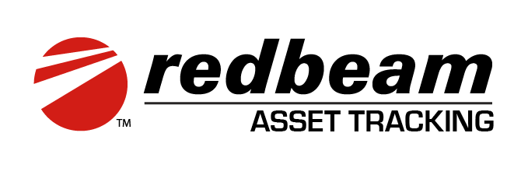

RedBeam Asset Tracking System (SaaS Edition)
Document Control & Release Notes
Software Version: v15.2.0.25
Platform Version: v3.66
Manual Version: 3.0 (Updated 2026)
Target Audience: System Administrators, Asset Managers, and Mobile Field Operators

Contents
RedBeam Asset Tracking System (SaaS Edition) 1
1. Overview 4
Interface Editions 4
System & Network Requirements 4
2. Getting Started & Onboarding Workflow 5
3. User Roles and Access Hierarchy 6
4. Application Navigation & Functions 7
4.1 User Menu & Profile Preferences 7
4.2 System Dashboard Analytics 8
4.3 Assets 9
4.3a Asset Data Categorization Tabs 11
5. Transactions: Check In & Check Out 13
Check-Out Process 13
Check-In Process 14
6. Physical Audit Lifecycle 15
7. Reports: Analytics & Exporting 16
7.1 Grid Customization & Filter Controls 17
7.2 Master & Transaction Reports 17
7.3 Historical Reports 18
7.4 Physical Inventory (Audit) Reports 19
8. Workflows 20
9. RFID 22
10. Label Printing & Setup 24
10.1 Printer Setup Procedure 24
10.2 Designing Label Templates 29
10.3 Sequential Printing 31
10.4 Printing From the Database 31
10.5 Configuring Metadata Fields & Values 32
11. RFID Mobile Workflows 35
RFID Mobile Functions 35
11.1 Tag Association Steps 35
11.2 Find 35
11.3 Mass Update 36
12 Document History & Maintenance Notes 36

1. Overview
The RedBeam Asset Tracking System (SaaS Edition) is an enterprise-grade, cloud-hosted platform deployed on Google Cloud infrastructure. Designed for rapid, reliable collection and lifecycle management of asset data, RedBeam supports full operational management via web browsers and field operations through handheld barcode and Zebra RFID mobile devices.

Interface Editions
- Full Web Console: Access via desktop, laptop, or tablet web browsers. Used for configuration, bulk operations, deep analytics, reporting, asset creation, and transaction management.
- Mobile Application: Access via rugged handheld computers, barcode readers, Zebra RFID readers, or smartphones. Optimized for rapid field updates, physical inventory counts, asset auditing, and check-in/out workflows.

System & Network Requirements
Platform / OS | Supported Browser / App Standard | Network Requirements
Windows / macOS | Google Chrome (Latest stable versions) | Internet connection required for real-time cloud synchronization
iOS / iPadOS | Safari (Latest stable versions) | Internet connection required for real-time cloud synchronization
Android (Mobile Devices) | Google Chrome (Latest stable versions) | Internet connection required for real-time cloud synchronization
Zebra RFID Field Handhelds | RedBeam Native Android Application from Play Store | Local Wi-Fi or cellular connectivity; Zebra DataWedge API support

2. Getting Started & Onboarding Workflow
To establish an organized tracking environment, adhere to the recommended implementation workflow outlined below.
Step | Phase | Primary Action | Recommended Tools
1a | System Setup | Define foundational organizational metadata (Locations, Departments, Categories, Statuses). | Setup Tab (Web Console)
1b (1a can be skipped if metadata is pre-defined within a spreadsheet or 3rd party integration) | Data Import | Bulk upload existing spreadsheet data into the Asset Grid. | Import Wizard (.xlsx, .csv)
3 | Tagging & Labeling | Generate and affix unique barcode or RFID tags matching Asset IDs. | RedBeam label printing or 3rd party label designer
4 | Operational Deployment | Perform physical audits, manage check-in/out transactions, and run compliance reports. | Mobile App / Web Console
Core Asset Identifier (Asset ID): The Asset ID is the immutable primary key for every physical record. It supports alphanumeric values up to 100 characters. Barcode scans and RFID tags must directly resolve to this unique ID string.

3. User Roles and Access Hierarchy
RedBeam enforces Role-Based Access Control (RBAC) to ensure administrative security and operational focus. Administrators may create custom roles
Feature Category | Administrator Role | Standard User Role | Custom Roles
Dashboard Overview | Full Access | Full Access | Configurable (Desktop/Mobile View)
Asset Management & Editing | Full Access (Create, Edit, Bulk Delete) | Standard View & Edit | Configurable per field/tab
Transactions (Check In / Out) | Full Access | Full Access | Configurable per device type
Inventory Management (Session Control) | Create, Open, Close, Configure Inclusion, Perform Counts | Perform Counts | Configurable per permission set
Reporting & Analytics | All Reports & Shared Filter Management | All Reports (Personal Filters Only) | Configurable per module
System Setup & API Access | Full Access | Restricted | Restricted by default

4. Application Navigation & Functions

4.1 User Menu & Profile Preferences
Located in the top-right header, the User Avatar provides quick access to account details and workspace preferences:
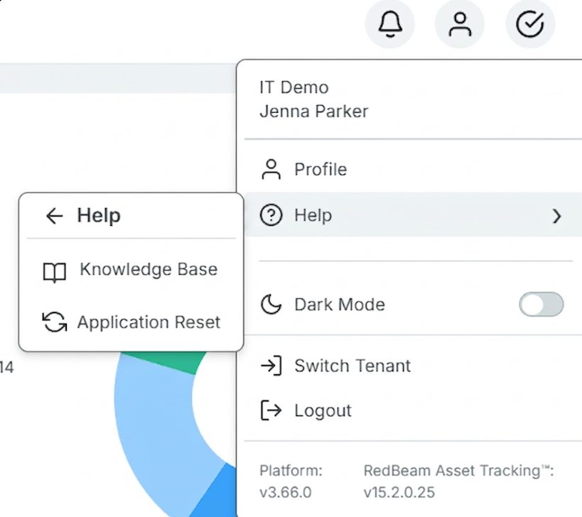
- Profile: View display name, email, contract ID, and assigned role. Allows secure password updates and offline pin updates.

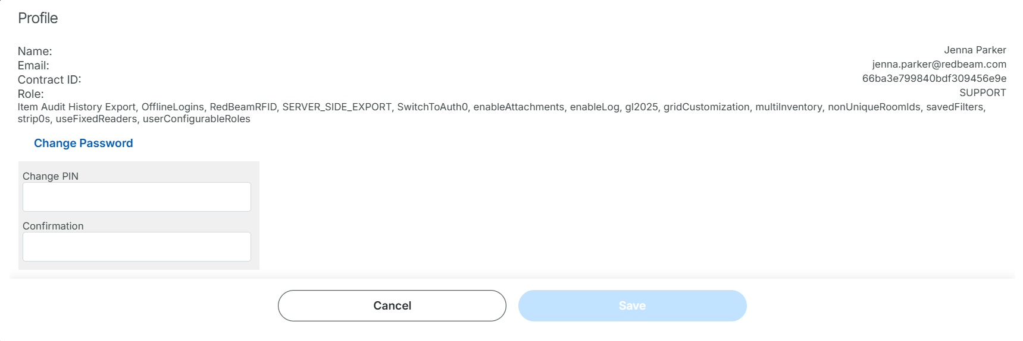
- Knowledge Base & Support: Direct access to technical documentation, release notes and ticketing services.
- Dark Mode Toggle: Inverts color palettes for enhanced visibility in low-light environment operations.
Warning — Application Reset: The Application Reset function forces a local storage sync reset. Any offline edits or pending background transactions that have not synced to the cloud will be permanently lost.

4.2 System Dashboard Analytics

The Dashboard opens upon login and serves as the central visual command center, aggregating high-level metrics and active audit metrics across your account.

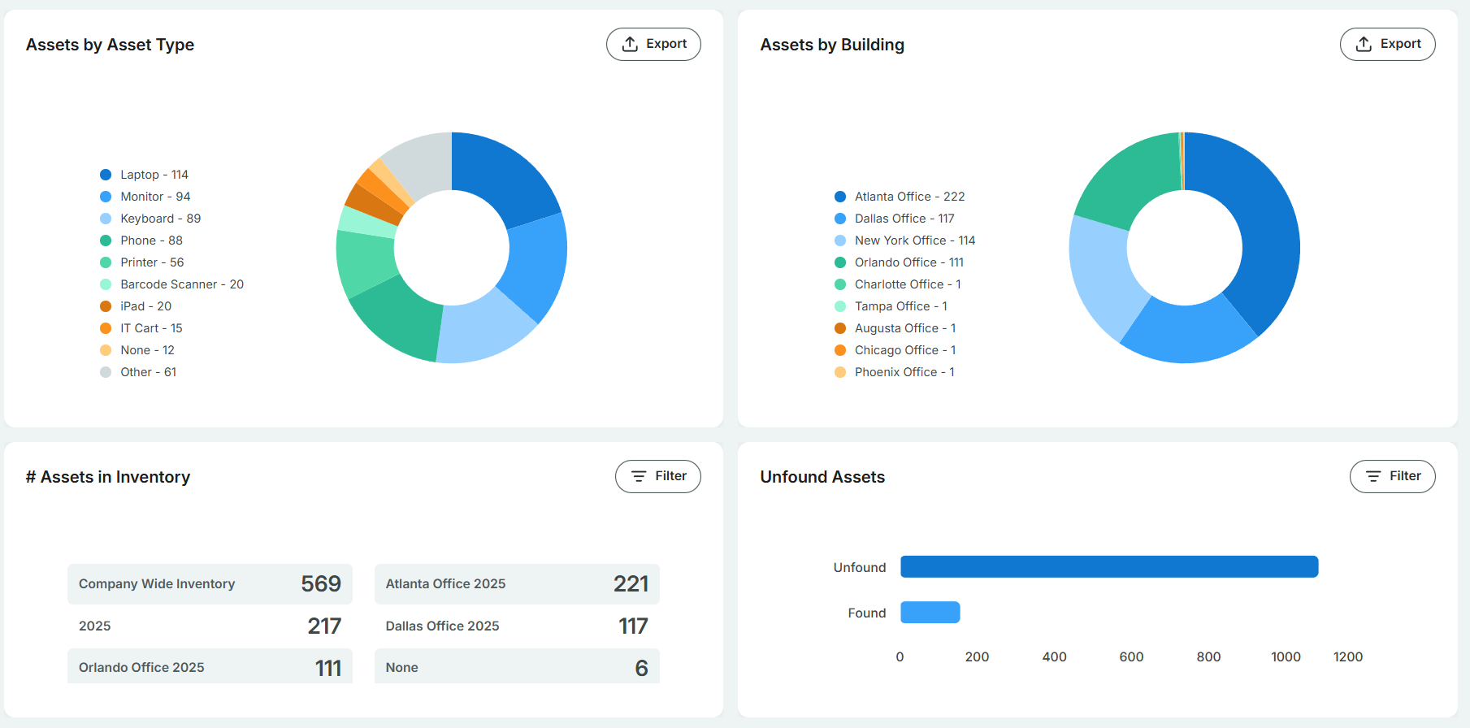

Dashboard Panel | Metric Description & Operational Purpose
Assets by Asset Type | Displays a visual distribution breakdown of total active assets categorized by type.
Assets by Building | Provides geographical distribution metrics across facilities and sites. Useful for multi-location asset density analysis.
# of Assets in Inventory | Displays the total number of items included in active inventory audit sessions. Users with multiple active sessions can select individual inventory sessions via a dropdown selector.
Unfound Assets | Provides audit reconciliation status, separating items into Found and Unfound states for active inventory sessions. Users with multiple active sessions can select individual inventory sessions via a dropdown selector.

4.3 Assets

The Assets grid serves as the central operational hub for managing items.

Key Asset Actions
- Manual Creation: Click the + button. Enter the mandatory Asset ID alongside optional descriptive attributes (Building, Room, Manufacturer, Model, Serial Number).
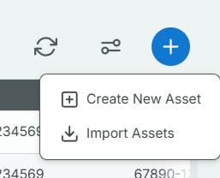
Batch Import: Upload spreadsheet files (xlsx or .csv). Map file columns to standard or custom RedBeam fields using the interactive mapping interface. New assets are created. Existing assets are updated.

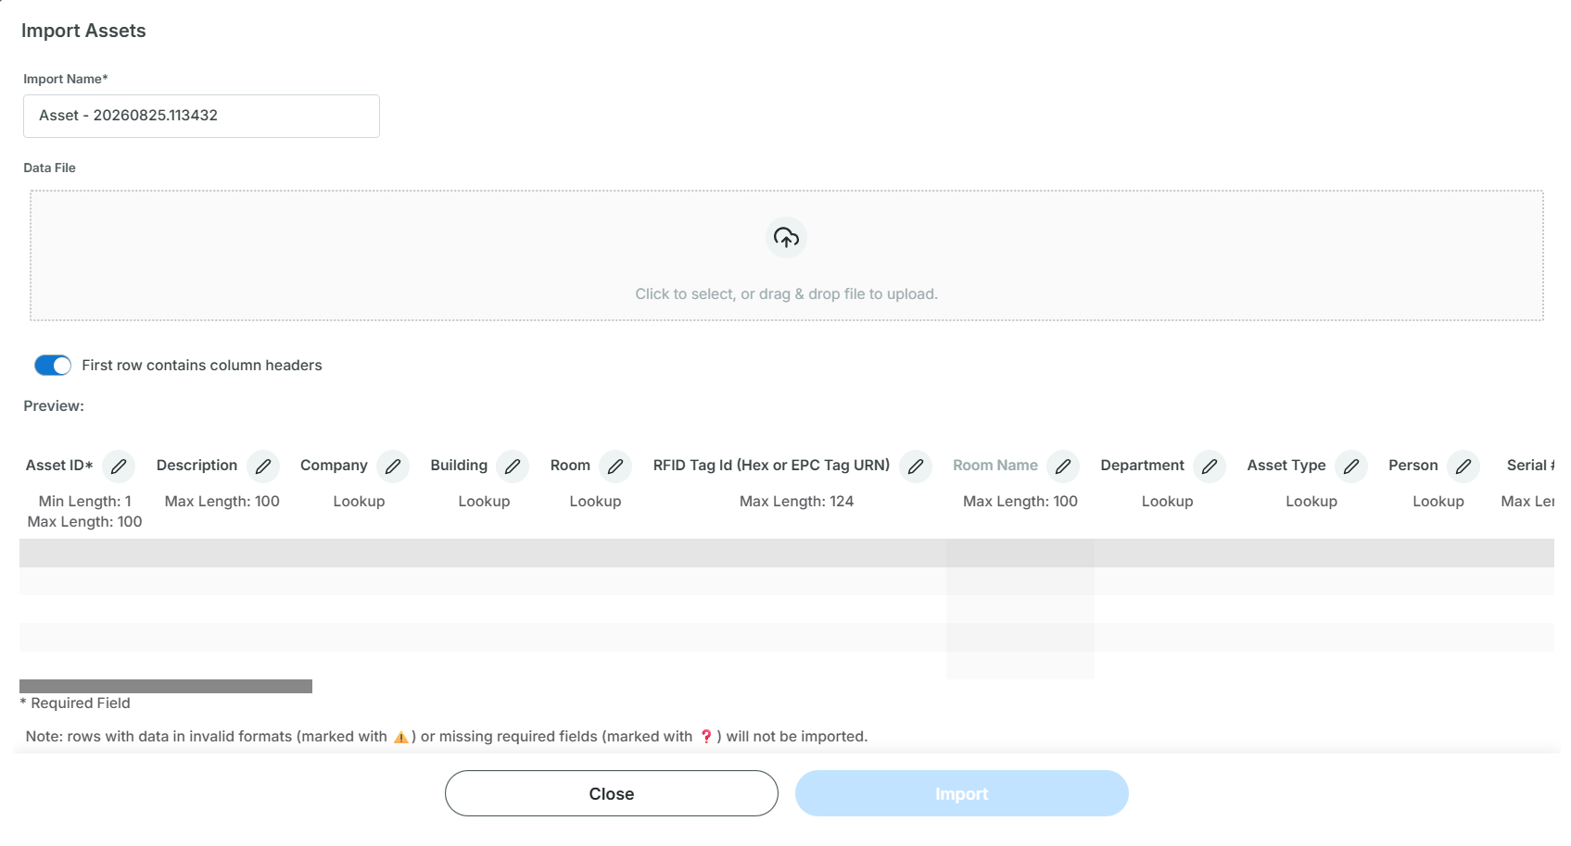
- Error Handling: If validation fails during import, RedBeam isolates the invalid rows and provides a downloadable error log identifying specific cell discrepancies.
- Column Customization: Click the column management icon in the top right corner to drag-and-drop column orders or hide non-essential data columns. Settings are stored on a per-browser basis.

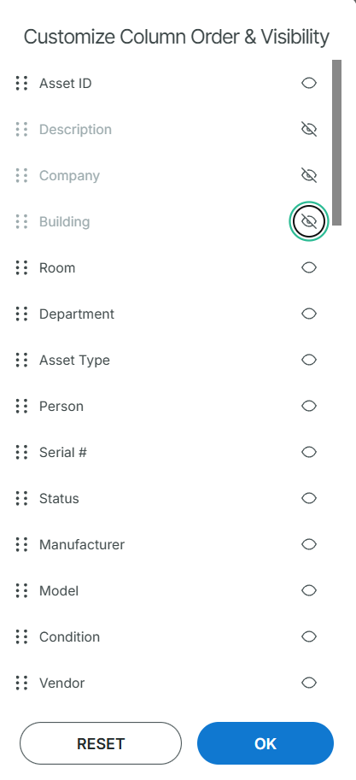

4.3a Asset Data Categorization Tabs
Tab Name | Key Data Fields & Capabilities
Details | Asset ID, Description, Company*, Building*, Room*, Department, Asset Type, Assigned Person, Serial Number, Status, Manufacturer, Model, Condition, RFID Tag ID, Notes.
Accounting | PO Number, Vendor, Financial Account, Acquisition Date**, Original Cost**, Scrap Value**, Recovery Period (Years)**, Lease & Warranty dates.
Checked Out | Active borrower details, Check-Out Timestamp, Reference Number, Associated Project, Expected Due Date.
Custom Fields | Customizable dropdown menus, free text entries, user-defined date selectors, and binary toggle switches.
Maintenance | Historical and scheduled service logs, work order notes, service cost tracking, and technician comments.
Attachments | Upload equipment manuals, receipts, or photos. Direct mobile camera integration for real-time visual inspection attachments.
Location History | Log recording every Company, Building, and Room update of the asset.
Audit History | Immutable audit log recording every data addition, alteration, clear event, user ID, and timestamp.
Ellipses (…) | Mark the asset is

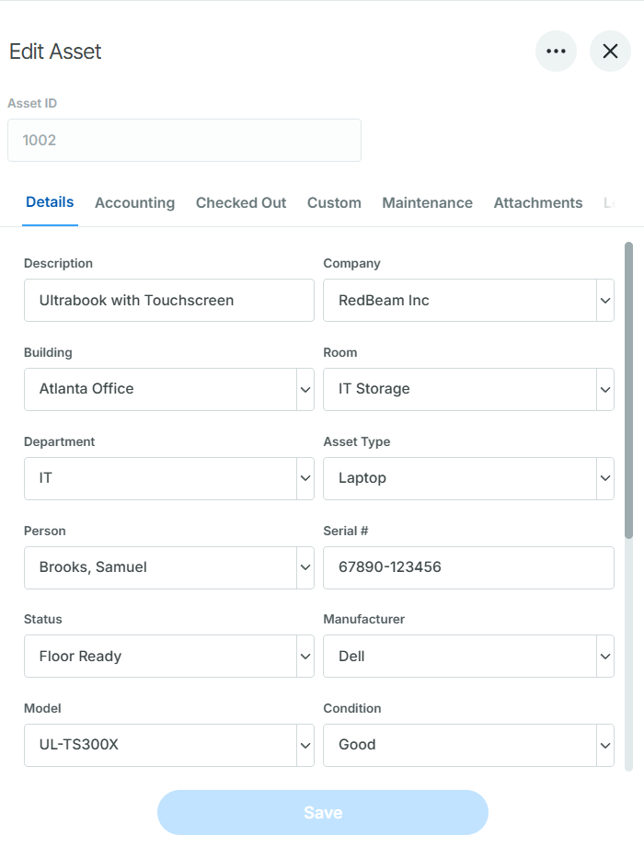

*Company, Building, and Room form a three-tier nested hierarchy: each room is assigned to a building, and each building is assigned to a company.

**RedBeam calculates straight-line asset depreciation automatically based on acquisition date, purchase cost, recovery period (years), and any optional scrap value. The scrap value is deducted from the initial cost prior to calculation. Depreciation accrues monthly starting at the close of the first full month after acquisition and ends when the asset reaches full depreciation.

5. Transactions: Check In & Check Out
Track short-term or temporary asset assignments to employees, contractor personnel, or project teams without changing the asset's permanent owner.

Check-Out Process
- Navigate to Transactions > Check Out.
- Select the receiving entity from the To (Person) dropdown or scan a Person ID barcode.
- Barcode or RFID scan / input the target Asset IDs into the selection list.
- (Optional) In the Details sub-tab, specify Due Date, Project Name, Reference Number, or temporary location overrides.
- Click Check Out to record the transaction.

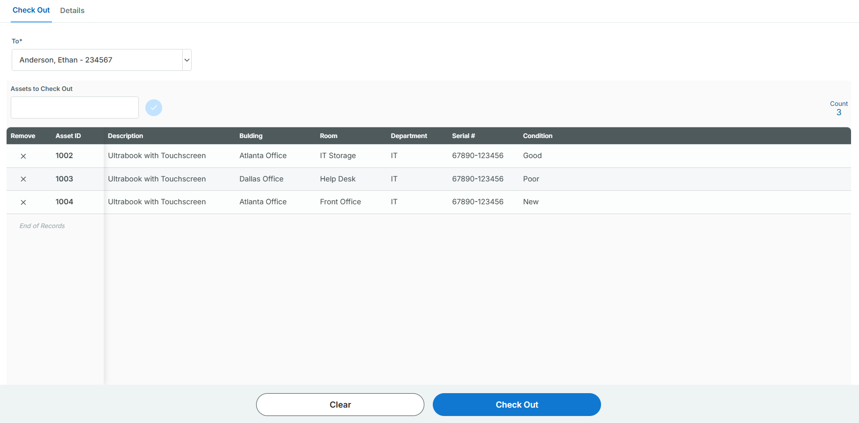

Check-In Process
- Navigate to Transactions > Check In.
- Set the target Destination Location (Company, Building, Room).
- Barcode /RFID scan or input the returning Asset IDs.
- If the target return room differs from the original assigned room, confirm the system location update prompt.
- Click Check In to complete processing.

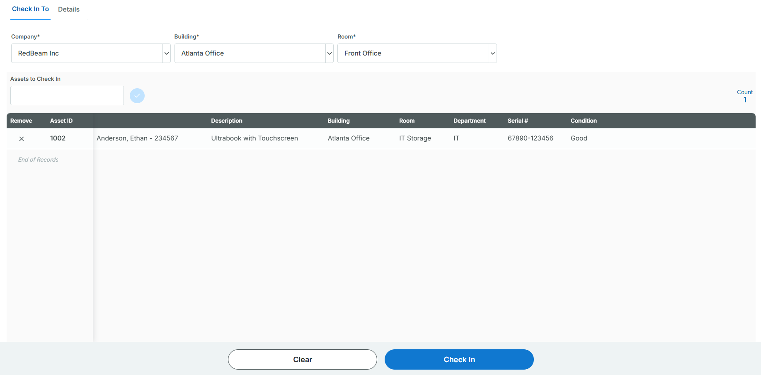

6. Physical Audit Lifecycle
- Session Setup & Scope Definition (Web Console)
  - Administrators open audit sessions under Inventory > Manage.
  - Sessions can be scoped globally across all sites or restricted by specific Companies, Buildings, or Rooms.
  - Multiple sessions can run simultaneously for different facilities without cross-contaminating audit data.
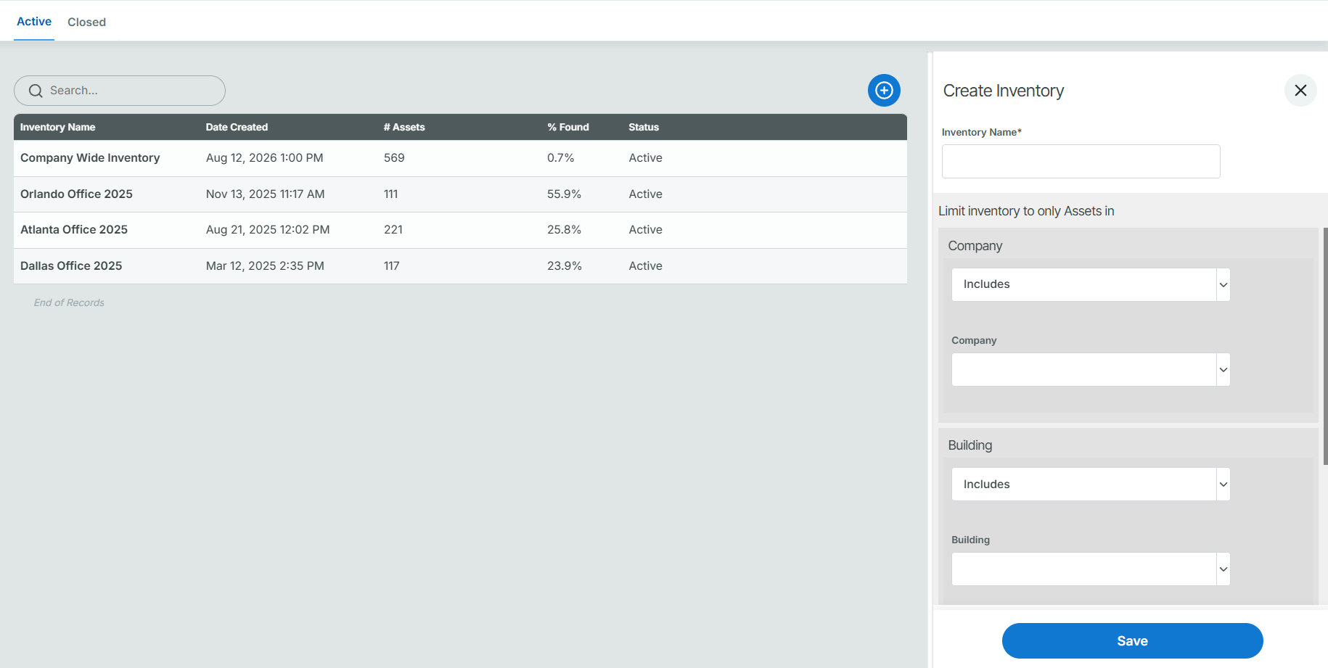
- Field Execution & Data Capture (Mobile / Web)
  - Operators navigate to Inventory > Count and select the active inventory session.
  - Selecting the current Company, Building, and Room isolates the expected asset list for that space.
  - Scanning an Asset ID or Serial Number marks the item as Found in real time.
  - Operators can make immediate field updates to metadata (e.g., Condition, Assigned Person, Status) of the asset.
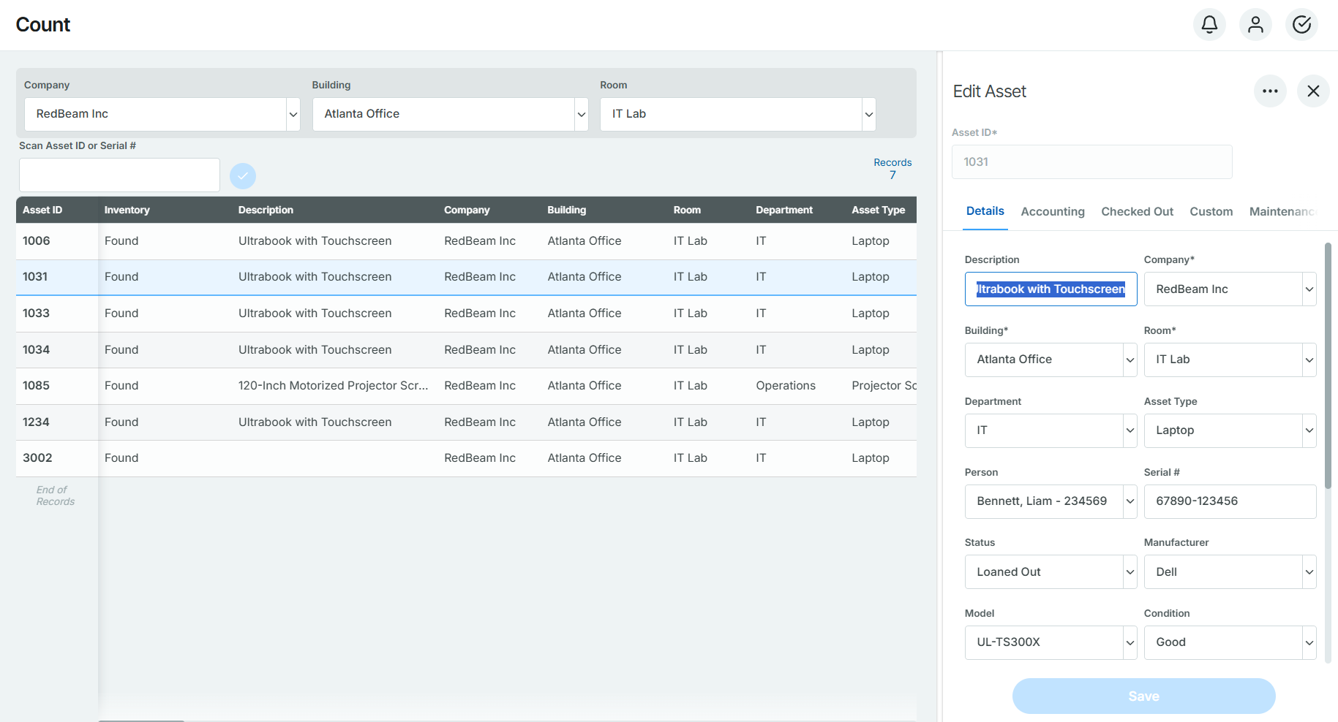
- Real-Time Exception Handling
  - Relocated Assets: If an asset is found outside its assigned room, the system notifies the operator and offers a one-click prompt to update the asset's location to the current room.
  - Unrecorded Assets: If an unmapped barcode or RFID tag is scanned, RedBeam prompts the user to register the new item into the database immediately.
- Reconciliation & Audit Closure
  - Administrators monitor real-time audit progress (% Found vs. % Unfound) via the Dashboard or Manage pane. More detailed reports are available from Reports > Inventory > Open.
  - Once field scans are complete, the session status is updated from Active to Closed.
  - Note: Closing an inventory session is permanent and prevents further scans, preserving the audit trail for financial reporting. Dedicated closed inventory reports can then be exported to Excel, CSV, or PDF.

7. Reports: Analytics & Exporting
The Reports engine provides comprehensive data filtering, customized views, and multi-format exporting across all database records, transactions, and audit sessions.

7.1 Grid Customization & Filter Controls
- Customizing Columns: Reorder or toggle the visibility of grid columns per browser using the column customization tool.

- Saved Filters: Save frequent filter combinations such as Personal Filters (private to your user account) or Shared Filters (administrators can publish account-wide saved filters).
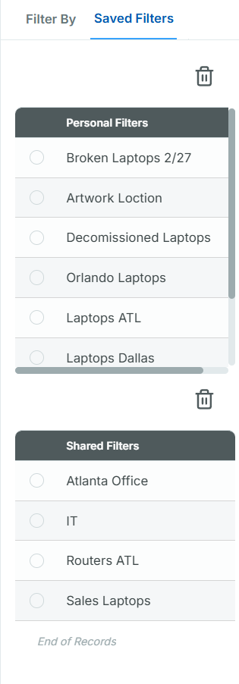
- Exporting Data: Export any filtered report data set to Excel (xlsx, .xls), CSV, HTML, or PDF.
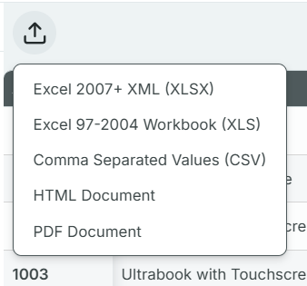

7.2 Master & Transaction Reports
- All Assets: Complete view of the entire asset database with filters for location, department, type, status, vendor, active state etc. Toggle between currently checked out assets and currently checked in assets and filter by check-out date, person, and project.

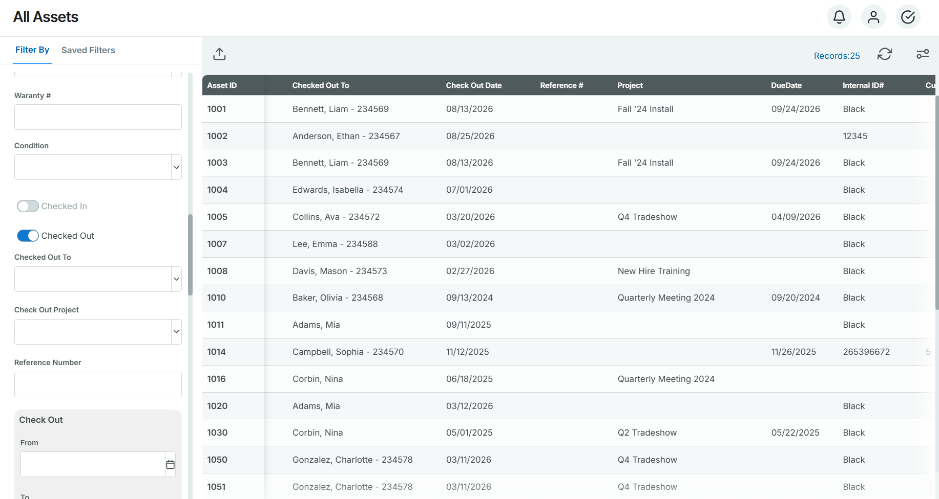
- Transaction History: Dedicated historical logs for tracking chain-custody over time of all check ins and check outs.

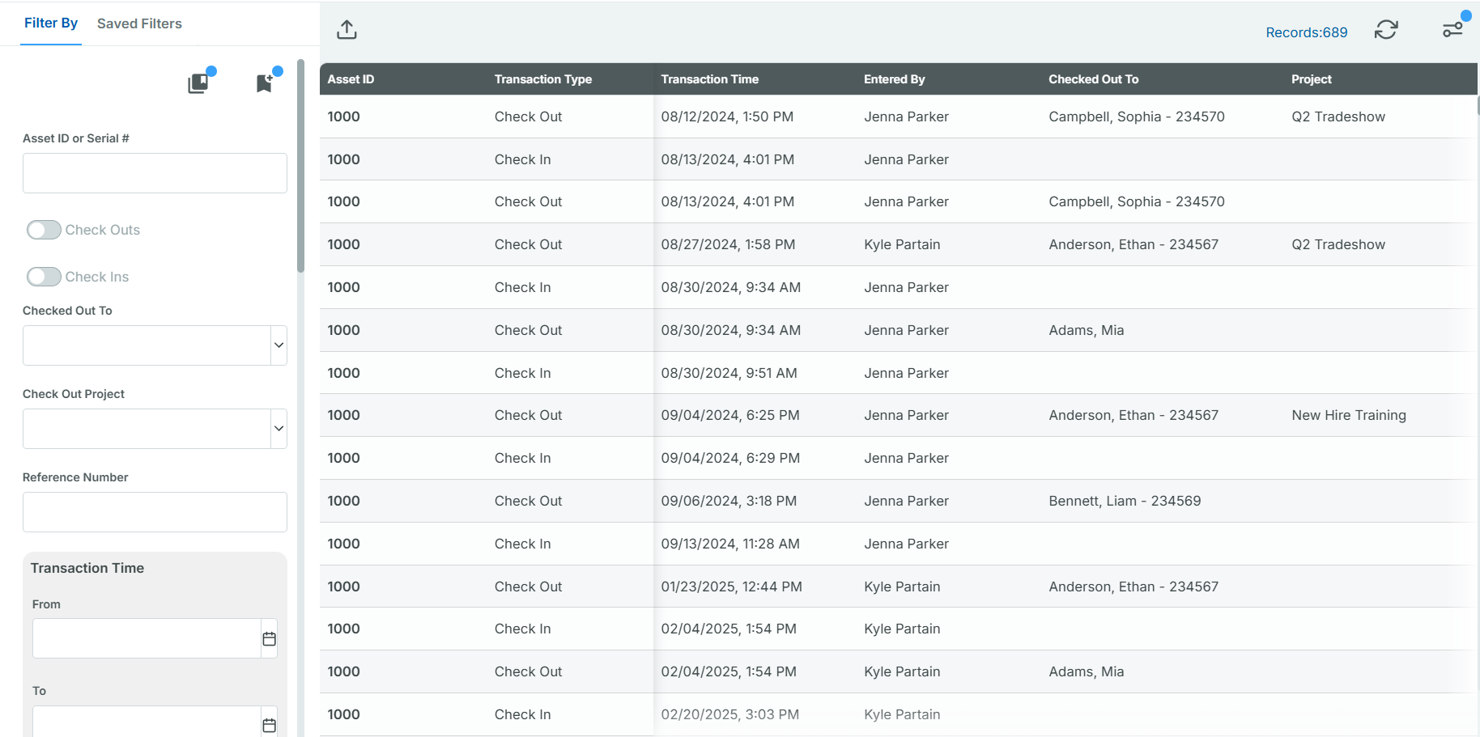

7.3 Historical Reports
- Location History: Log highlighting every asset movement, timestamp, where the asset moved, and which user or RFID fixed reader performed the action.
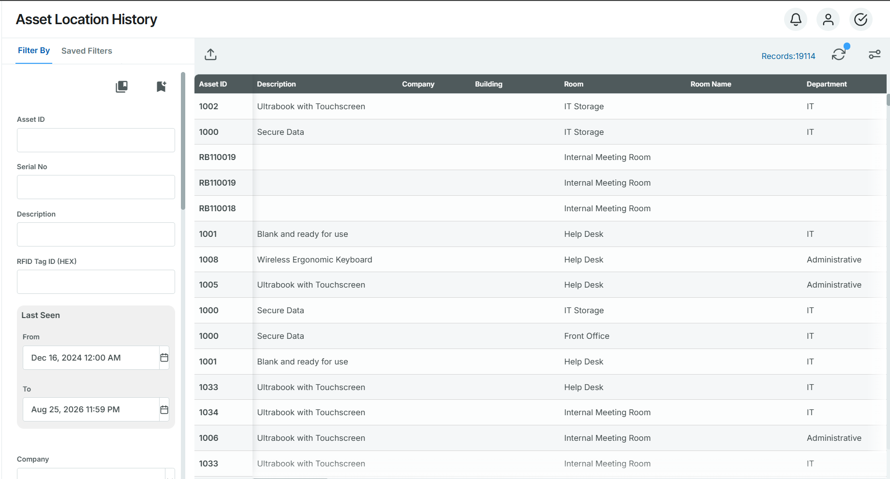
- Audit History: Detailed trail logging every record modification, timestamp, field change, and the specific user who performed the action.
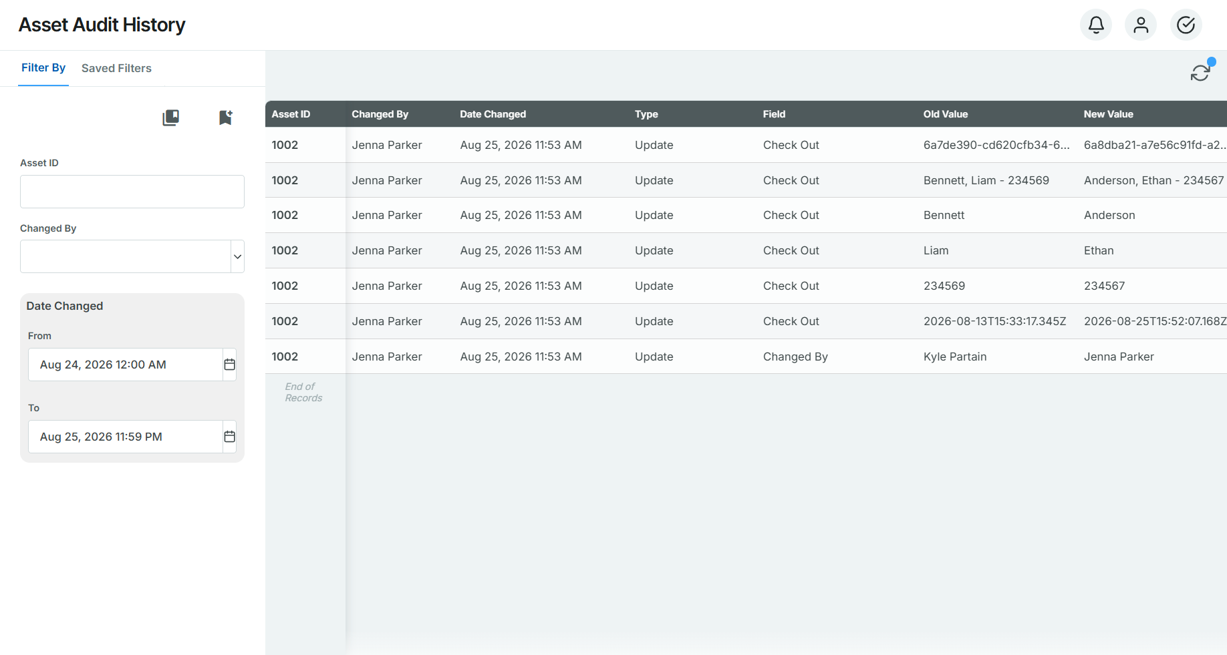

7.4 Physical Inventory (Audit) Reports
- Open Inventory Reports: Filter real-time progress for active audit sessions:
  - All Assets / Found / Unfound: Reconcile recovered items against missing inventory.
  - Discrepancy Sub-Reports: Isolate items flagged with New Room, New Serial #, New Status, or New Asset (unregistered items added during scans).
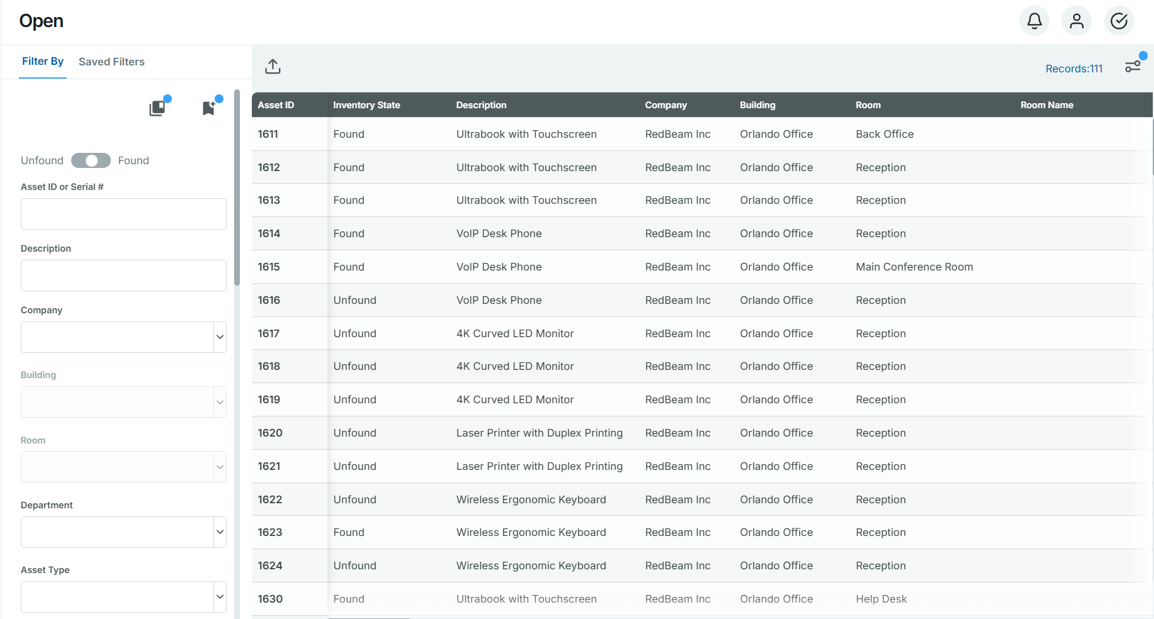
- Closed Inventory Reports: Permanent, read-only audit snapshots archived after session completion for compliance and financial reporting.
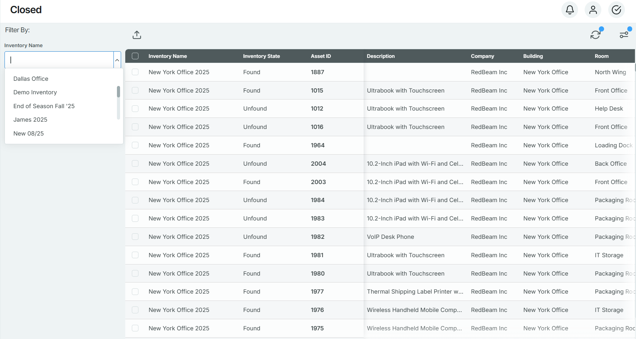

8. Workflows
The Workflows module allows administrators to create custom "if-then" automation rules that trigger real-time actions based on system events or RFID read activity. While RFID readers capture what, when, and where an asset was detected, workflows apply business logic to that data, automating notifications, status changes, physical hardware signals, and third-party webhooks without manual intervention.

Creating a Workflow
- Navigate to Workflows and click the + button in the action bar.
- Enter a descriptive Workflow Name and Description.

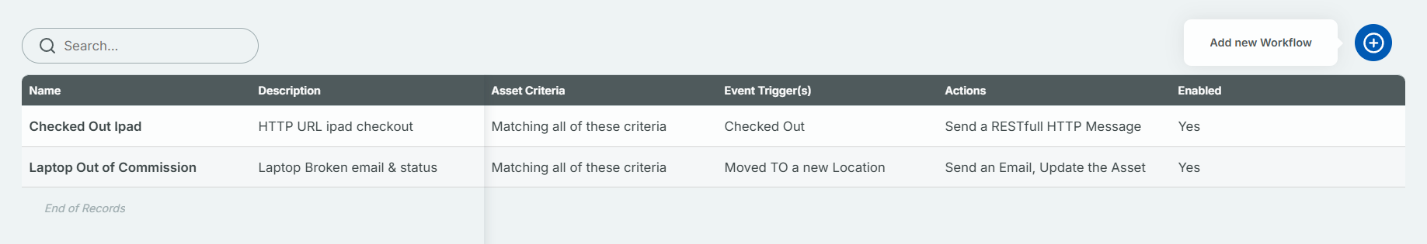

Configuring Trigger Conditions ("IF" Statement) The "IF" section establishes the specific criteria and events required to activate the workflow:
- Item Selection: Click + to specify which asset categories, types, or individual items are evaluated by the rule.
- Update / Event Type: Define the exact trigger condition (e.g., when a tag enters or exits a designated location).
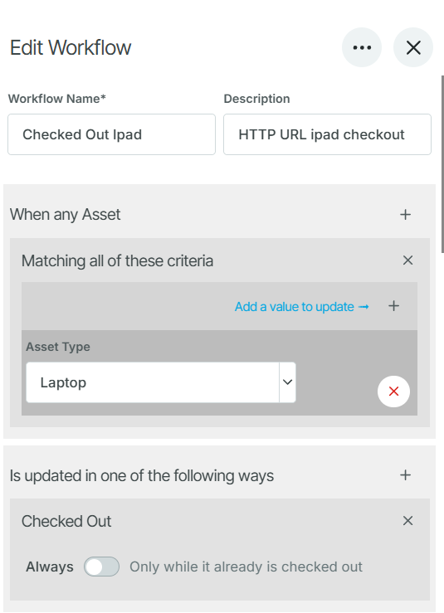

Defining Automated Actions ("THEN" Action) Once trigger conditions are met, define one or more automated actions to execute:
- Send an Email: Automatically dispatch notification emails to single or multiple recipients (separate email addresses with commas).
- Update an Asset Field: Automatically update specific database attributes (e.g., changing an asset's status or condition).
- Activate GPO: Send a General-Purpose Output (GPO) signal to trigger external physical hardware, such as stack lights or audible alarms.
- Send RESTful HTTP Message: Post a JSON payload or notification to a custom REST API endpoint.
- Forward over MQTT: Publish event telemetry to an MQTT broker for real-time IoT integration.

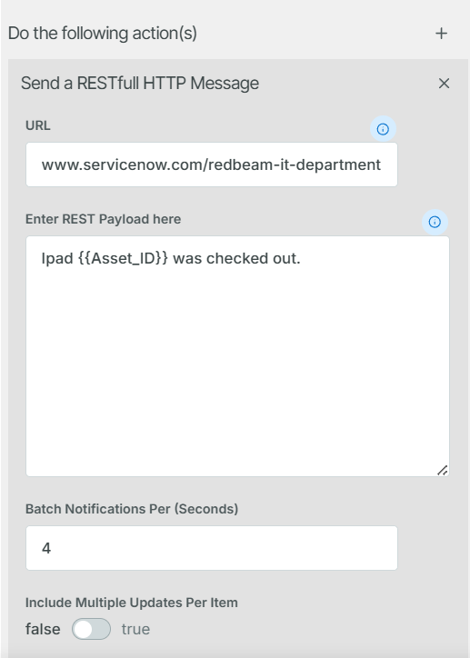

Using Dynamic Message Variables When configuring Send an Email or RESTful HTTP Message actions, insert dynamic variables into the message body to populate real-time event data:

9. RFID
The RFID module manages networked fixed RFID readers, antenna configurations, and system-wide read profiles. Fixed readers collect real-time asset movement data and stream updates directly to RedBeam.

1. Managing Fixed RFID Readers: Fixed readers auto-register with RedBeam when connected to an internet-enabled network. Pre-configuration is also supported for hardware deployments requiring setup prior to on-site installation.

- Auto-Registered Metadata: Connected readers automatically populate IP Address, Device Type, MAC Address, and Firmware Version.
- Adding a Reader Manually: Click Add (+), then specify the Hostname, Company, and Building. (Note: Saving unlocks the Edit and Device Settings tabs.)
- Editing/Deleting Readers: Select a reader from the grid to modify fields in the right-side detail pane, save changes, or delete the record.
- Heartbeat & Offline Alerts:
  - RedBeam tracks reader connectivity using a background heartbeat interval.
  - If a reader fails to respond after three consecutive intervals, its status changes to Offline = Yes.
  - Toggle Offline Email = Yes in Device Details to automatically notify system administrators upon connectivity loss.

- RFID Reading & Antenna Configuration: The RFID Reading sub-tab configures hardware ports and antenna coverage zones.
- Adding Antennas: Select the target Company and Building, define the reader's port count, and click + to map antennas.
- Core Antenna Parameters:
  - Location (Mandatory): Maps the antenna to a specific physical location. When a tag is read, the asset's location in RedBeam automatically updates to this zone.
  - % Power: Controls the read range (scale: 1 to 100). If an antenna port requires 0 power, delete the antenna record.
  - Cool Down: Sets the delay (in seconds) before the same antenna can log consecutive reads of a single tag.
  - Port: Assigns the physical port number on the fixed reader.

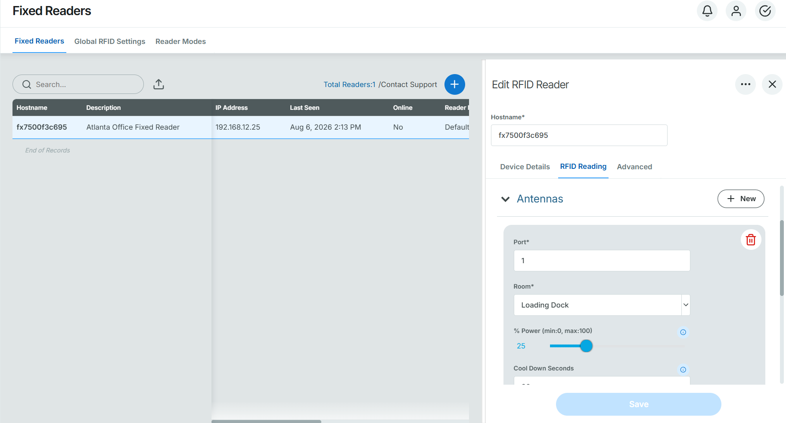

10. Label Printing & Setup
RedBeam seamlessly connects with networked thermal barcode printers (such as Zebra ZD/ZT series) via standard web utilities.

Printer Setup Procedure
Before labels can be printed from RedBeam, the printer must be connected to a network, and the IP address will need to be configured within RedBeam.

- Load tags into printer.
- Connect one end of a network cable to the rear of the printer and the other into an available network port.
- Plug the power adapter into the rear of the tag printer and plug the power cable into an available AC outlet.
- Power on the printer by pressing and holding the power button for about 5 seconds and then release the power button.
- Press and hold the Feed and Cancel buttons for two seconds and then release to print a configuration page. By default, a new tag printer will obtain an IP address via DHCP.
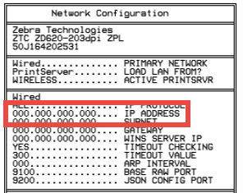
- Download the Zebra print utility here.
- Right click on that downloaded file name zebra-browser-print-windows-v131445(.exe) and select Properties > Compatibility > Change high DPI settings.
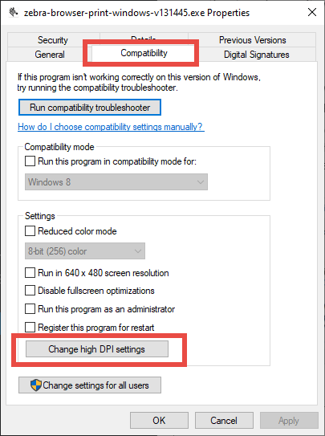
- Check both boxes and select System from the dropdown. Then click Ok, and Ok again.
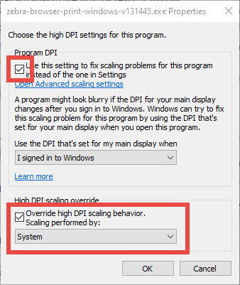

- Double click the file zebra-browser-print-windows-v131445(.exe) to start the installation and click Next until install. Click Install. Ensure the box is checked “Launch Zebra Browser Print” before clicking Finish.
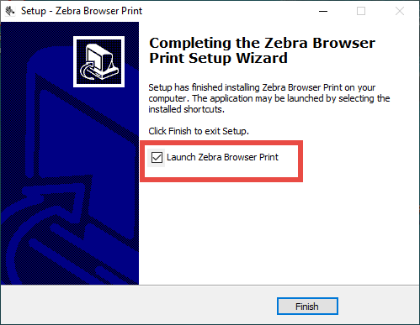
- You will receive a message that security needs to be accepted. Click OK.
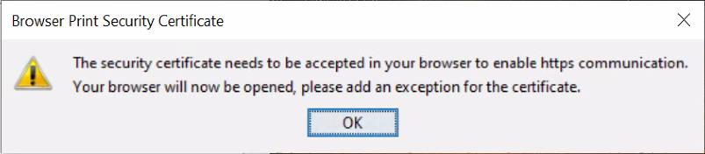
- Then you will see a webpage showing your connection isn't private. Click Advanced and click Continue to localhost.
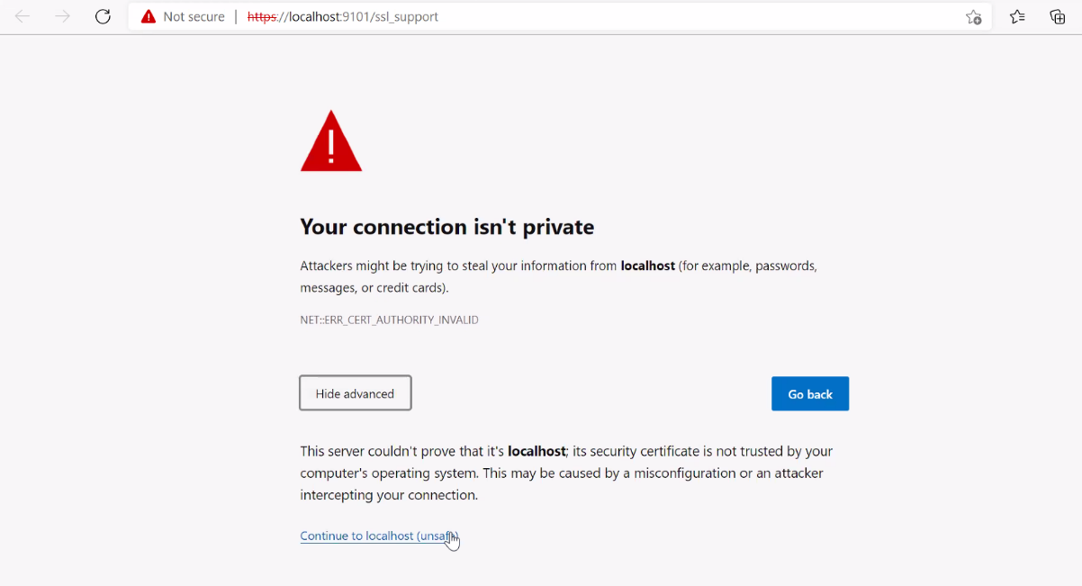
- Select Yes to give your computer access to the Zebra printer.
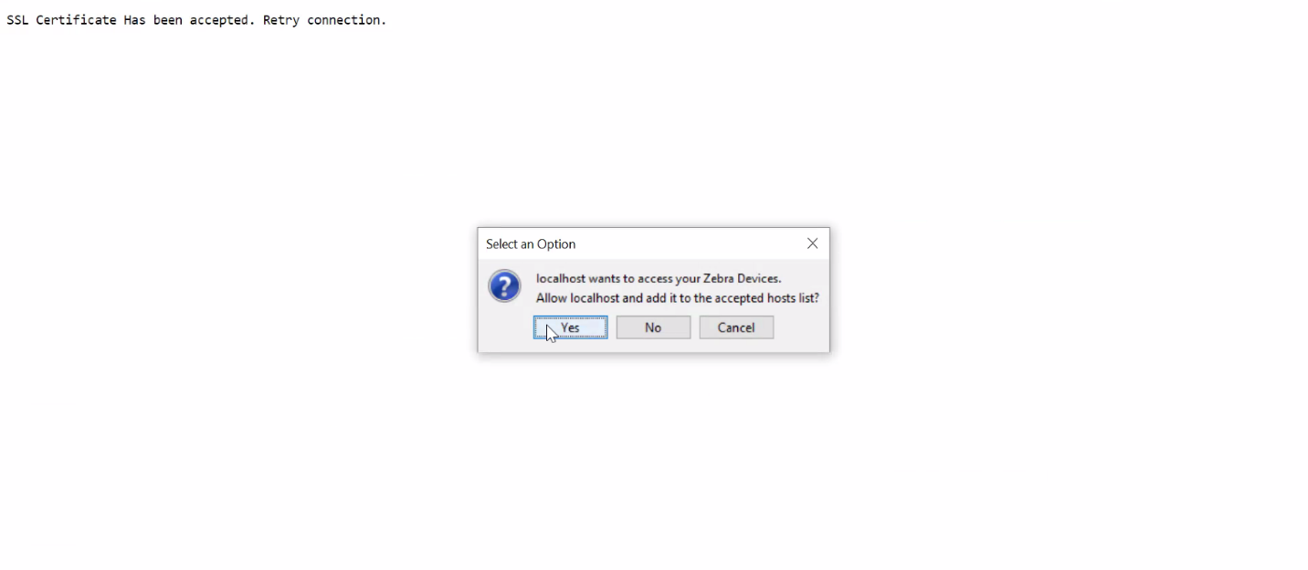
- Open your task tray at the bottom right and select Browser Print.
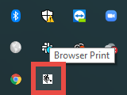
- Under Added Devices, select Manage.
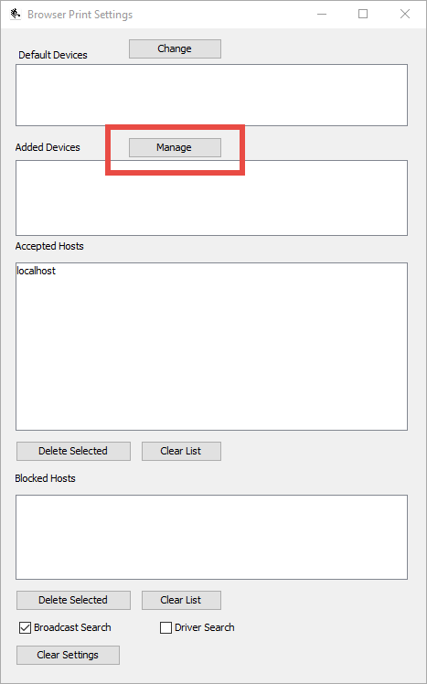
- Enter any printer name as you would like it to appear. Then enter the printer's IP address (from step 5) for Device Address and click Add.
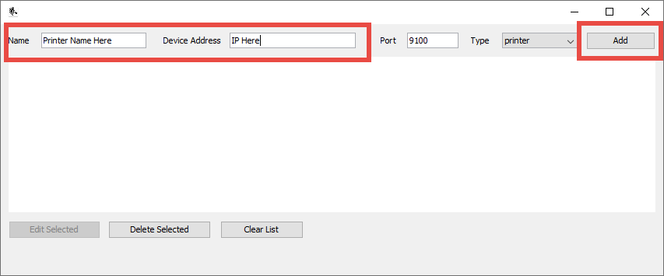
- Login to your RedBeam account and go to the Assets page.
- Check the box for any asset, click Select Action, click Print Labels.
- 15. Select the printer from the dropdown.
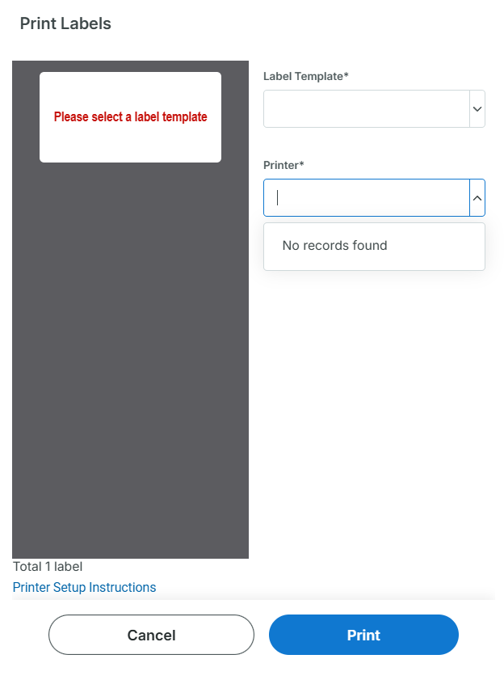
- Click Yes to allow RedBeam access to your Zebra printer.

Designing Label Templates
The Label Template module enables administrators to design custom asset, room, and person label templates.

- Navigate to Setup > Label Printing > Label Templates and click the + button.
- Enter a descriptive Template Name (e.g., Standard Asset Tag 2x1 or Location Label).
- Under Label Content, click + to add design elements:
  - Fixed Text: Displays static text that appears on every printed label (e.g., "Property of Company X").
  - From Field: Dynamically pulls database values from the selected Asset, Room, or Person record (e.g., Asset ID, Description, Room Name).
  - Barcode: Renders a scannable 1D barcode alongside its human-readable text value.
  - QR Code: Renders a scannable 2D barcode.
  - RFID: Signals that the tag will be encoded with an RFID Tag ID.
  - Custom ZPL: Copy and paste custom code for specific label dimensions and design.
- Click Save to store the layout.

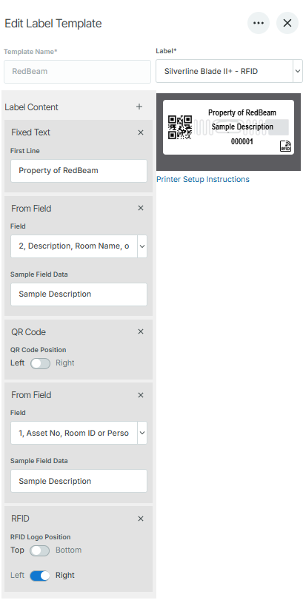

Sequential Printing
For new asset implementations without existing tags, administrators can print batches of numbered labels in advance:

- Go to Setup > Label Printing > Sequential Printing.
- Enter the Start number (e.g., 100) and End number (e.g., 500).
- (Optional) Configure formatting options:
  - Prefix: Appends text before the number (e.g., AST- produces AST-100).
  - Increment (Update): Adjusts step values (e.g., setting to 2 prints 100, 102, 104).
  - Pad to Length: Sets fixed digit counts with leading zeros (e.g., padding 100 to 5 digits produces 00100).
- Select the target Printer and Label Template, preview the output, and click Print.

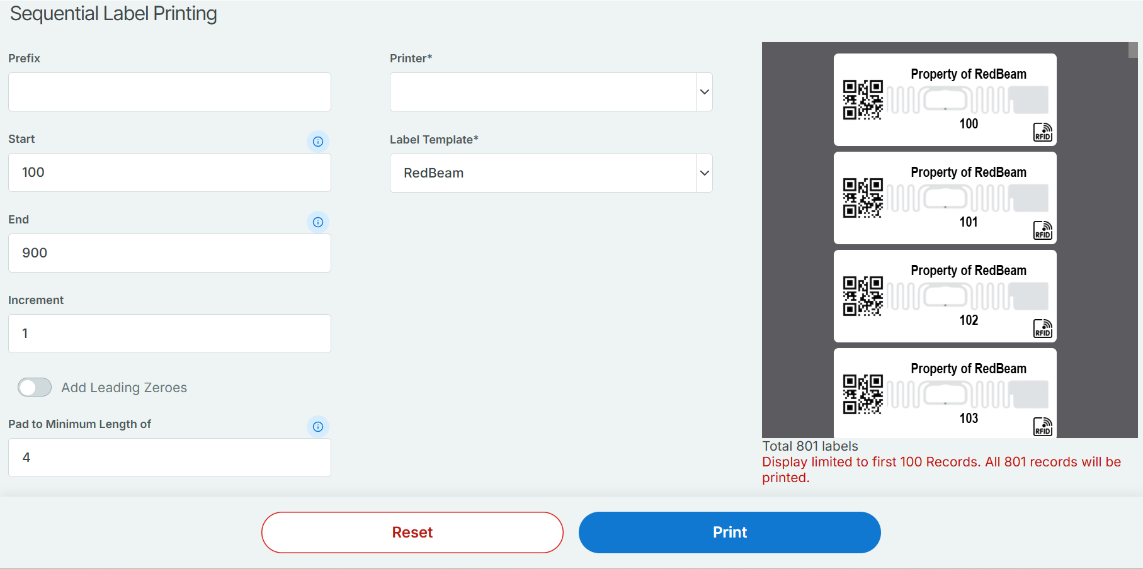

Printing From the Database
Users can print barcode labels directly from the web console using pre-configured printer templates:

- Select Target Assets: Navigate to the Assets tab and check the boxes next to the assets requiring labels.
- Open Print Dialog: Click the Select Action icon > Print Labels.
- Configure Settings: Choose the connected Printer and select the desired Label Template from the dropdown menus.
- Preview & Print: Review the label preview panel and verified print count, then click Print to send the job to the label printer.

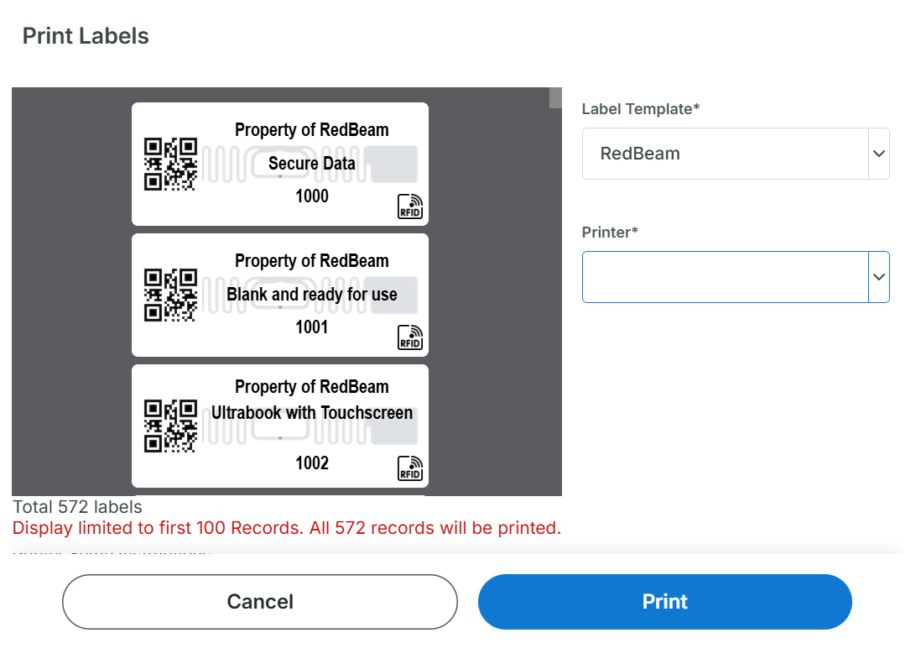

Configuring Metadata Fields & Values
The Setup module allows administrators to establish drop-down options, organizational attributes, physical locations, and system access controls.

1. Physical Locations (3-Tier Hierarchy) RedBeam uses a strict three-tier nested location hierarchy to organize assets:
- Companies: The top level of the hierarchy. Stores organization name, primary address, and contact details.
- Buildings: Assigned directly to a Company. Stores facility name, street address, and site contact info.
- Rooms: Assigned directly to a Building. Rooms are the mandatory location unit required when conducting physical inventory audits or checking in assets. Note: Room ID barcode tags can be printed directly from the Rooms grid.
- Note: Company, Building, Room can be renamed under Setup > Customization > Field Settings.
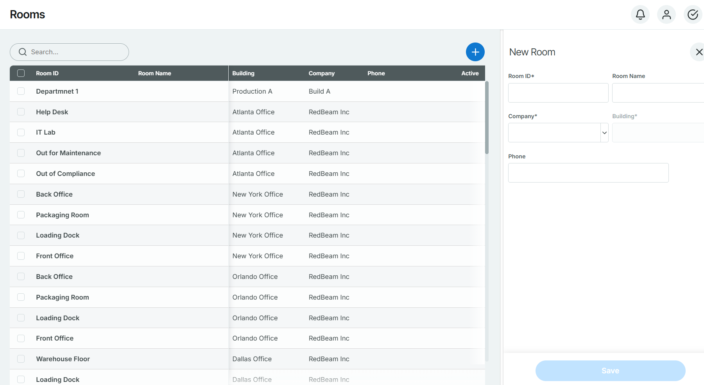

2. Asset Data Attributes Define standard dropdown options used across asset records:
- Departments: Non-location-based organizational divisions responsible for assets (e.g., IT, Human Resources, Facilities).
- People: Individual employees or personnel who hold assets long-term or check them out temporarily. Stores full name, email, job title, and Person ID. Note: Person ID barcode tags can be printed directly from the People grid.
- Projects: Project codes or job names assigned to assets during check-out transactions.
- Asset Types: General classifications describing the equipment category (e.g., Computers, Vehicles, Furniture).
- Manufacturers & Models: Brands (e.g., Dell, Ford) and specific model names/numbers.
- Vendors & Accounts: Purchasing suppliers and financial reference accounts (GL accounts, cost centers, or grant numbers).
- Conditions & Statuses: Subjective health metrics (New, Good, Fair, Poor) and operational states (In Use, Out for Repair, Retired).
- Custom Dropdowns: Five fully configurable dropdown fields managed via Setup > Custom Fields and renamed via Setup > Customization > Field Settings.

3. System Access & Administration
- Customization: Allows administrators to customize field labels and rename the five custom dropdown fields to align with company terminology.
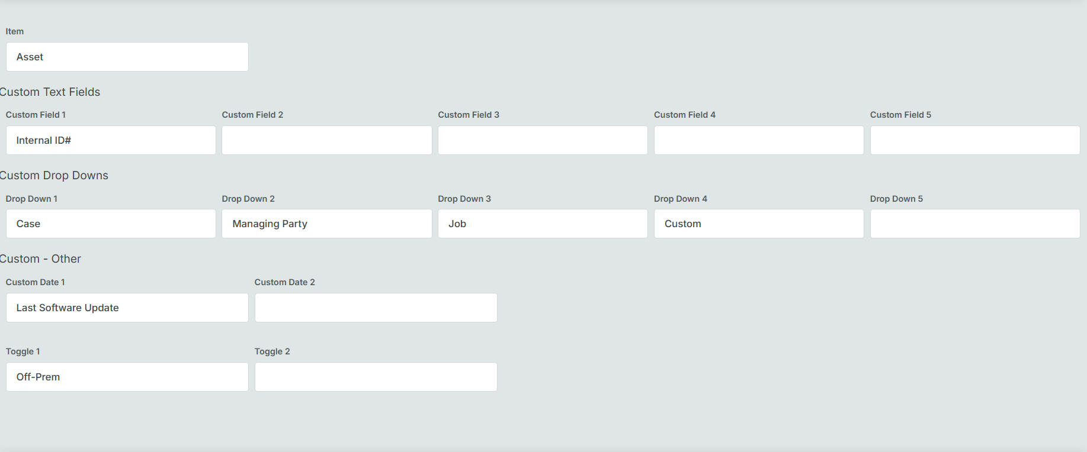
- API Access: Generates RESTful API credentials to integrate RedBeam with external ERP, ITAM, or HR systems.
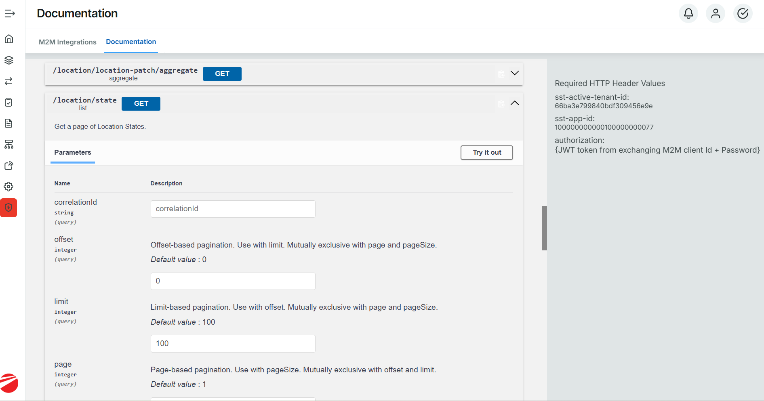
- Users & Roles: Manage user seats and configure granular Role-Based Access Control (RBAC) per page, device type (Desktop vs. Mobile), and specific operational feature.
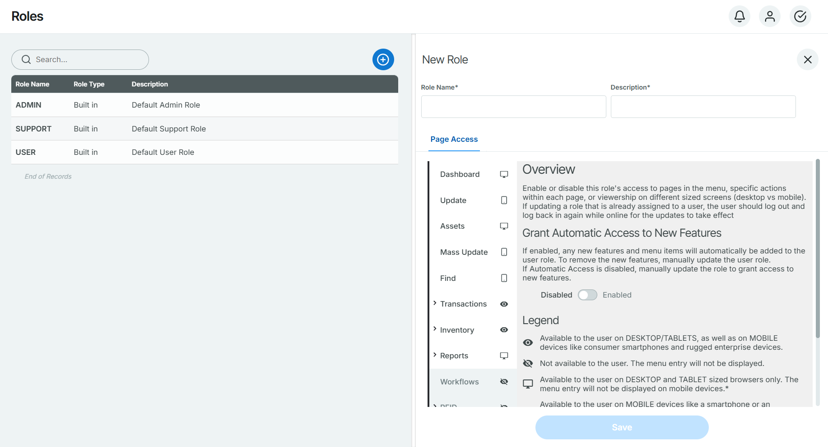

11. RFID Mobile Workflows

RFID Mobile Functions
RedBeam RFID technology leverages pre-encoded Tag IDs manufactured directly into UHF RFID tags, eliminating manual encoding steps.

11.1 Tag Association Steps
- Open the RedBeam Native App on a supported RFID mobile terminal.
- Navigate to Assign RFID.
- Set the RF Power Slider to a low threshold to prevent cross-reading adjacent tags.
- Scan or input the target Asset ID.
- Pull the RFID reader trigger to pair the tag's internal Tag ID to the Asset ID record.
- Confirm the "Tag Association Successful" notification.

11.2 Find
The Find function helps operators home in on a specific asset using RFID signal strength tracking.
- Filter the Search: Enter the target Asset ID
- Locate the Asset: Tap the desired item in the grid to activate RFID tracking and walk slowly through the search area.
- Follow the Signal: As you get closer to the tag, the on-screen signal meter will display additional bars, and the device's audible beeping will increase in speed.

11.3 Mass Update
The Mass Update feature allows operators to update specific field values for multiple assets at the same time using RFID scanning

- Adjust Read Range: Use the RFID Power slider to decrease or increase the mobile reader’s detection distance as needed
- Scan Assets: Pull the trigger on the RFID reader to detect nearby tagged assets. The detected Item ID and Tag ID will populate in the grid. (Note: Pulling the trigger again continues adding newly detected tags to the list.
- Apply Updates: Click the + (Blue Plus) button to select the specific fields and values you want to modify across all selected items
- Save or Clear:
  - Click Save (✓) to apply and store the updates
  - Click Clear (X) to reset the grid without saving changes

12 Document History & Maintenance Notes
This user manual is updated periodically alongside platform software releases. For technical assistance, integration of API docs, or order placement for pre-printed labels, contact support through your user panel or directly at redbeam.com.

